**Variable Path Generator**

**Variable Path Generator** is an updated and more robust version of JSON Path Generator.

**Advantages:**

* Reduces the time of manually traversing the JSON file hierarchy to generate the path of a Class Name.
* Reduces the time of manually typing the then recognized path in the function.
* Returns the output in Variablized form.
* Accepts more than one Class Name.
* Avoids multiple addition of Class Names referring to same element.
* Generates Variablized Path for hierarchical path name of an element.

**Example:**

Time consumed to find the Variablized Path of **.mpageui-DataSection-content .mpuui .mpageui-ResponsiveButtonGroup:nth-child(5) .j_password** and Call it in the function.

**Manually:** 5 minutes 23 seconds

**Variable Path Generator:** 30 seconds

**Points to Remember:**

* Insert a **“.”** Before each Class Name.

**Path to Install the Application:**

<https://github.cerner.com/wd050729/Variable-Generator>

**How to Use:**

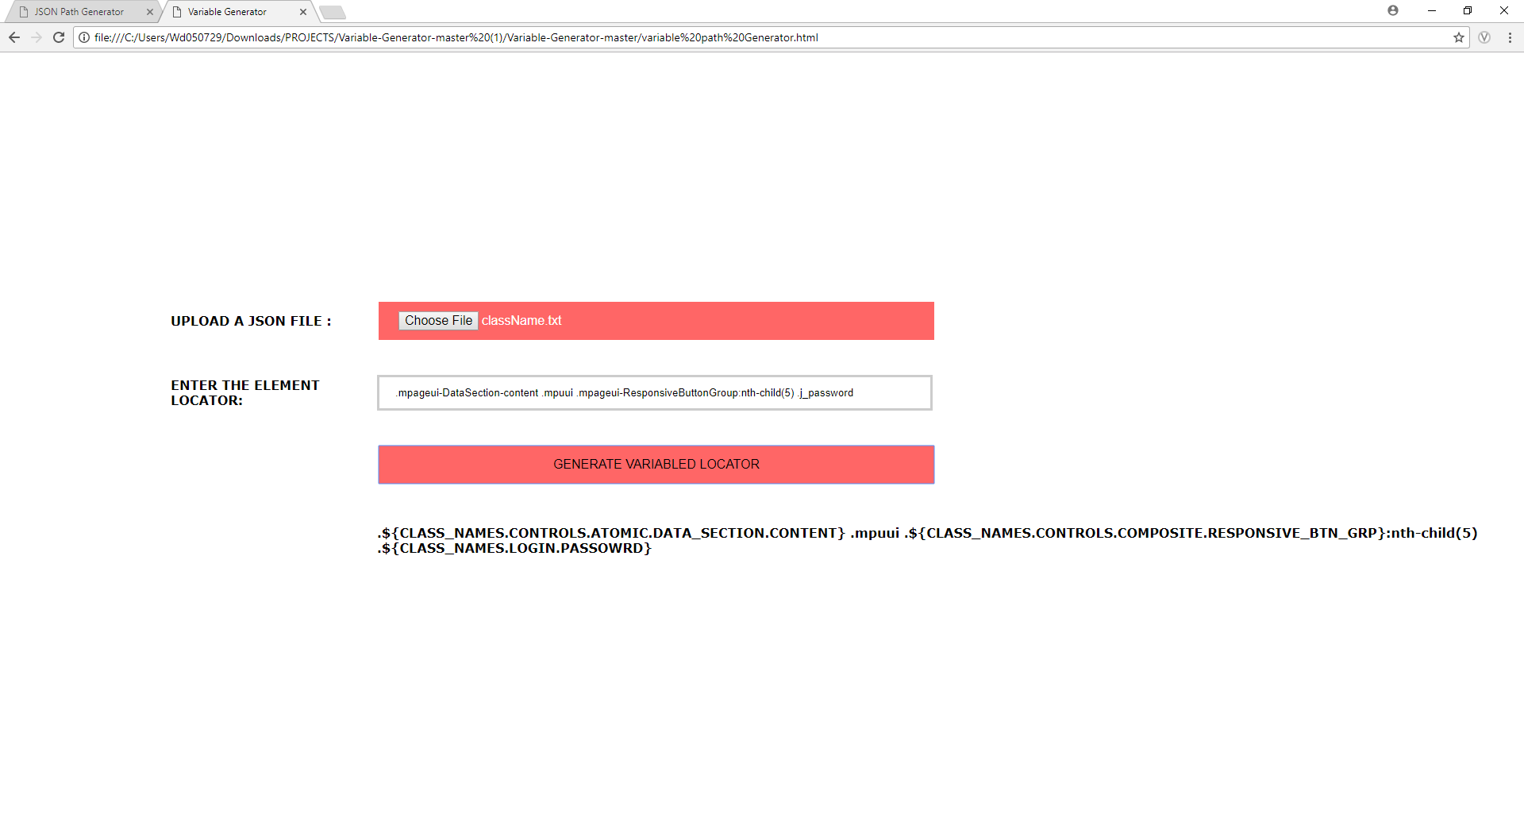

1. Clone the repository to local machine from the above link.
2. Unzip/Extract the files.
3. Open the Variable Generator html file.
4. Click on the Choose File button and import the Class Name file.
5. Enter the **Class Name or Multiple Class Names or Hierarchical Class Names** to which the Path is required.
6. Click on the GENERATE VARIABLED LOCATOR button.
7. Copy the text generated below and paste it in your function.

**Predecessor:**

**JSON Path Generator**